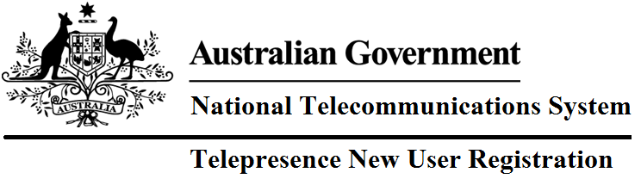

**Email:**

This is used to login, and receive notifications.

Use your **.gov.au** email address if you have one. Requests with other emails may be subject to increased scrutiny by Concierge personnel.

**Salutation: 🗖Miss 🗖Mr 🗖Mrs Other**

**First Name:**

**Surname:**

**Organisation:**

**Position:**

**Phone (Office):**

**Phone (Mobile):**

**Address:**

**Street Address:**

**Include Building Name**

**City**

**State/Territory**

**Postcode**

**Time zone:**

**🗖 UTC+10:00 (Brisbane, Sydney, Canberra, Melbourne, Hobart)**

**🗖UTC+9:30 (Darwin, Adelaide)**

**🗖UTC+8:00 (Perth)**

**🗖Other Please Specify**

**Justification to access NTS Online Booking System:**

**🗖Make bookings for myself**

**🗖Make bookings for others**

**🗖To view bookings**

**🗖I am a Telepresence Systems Admin**

**🗖Other (Please Specify)**

Please email a scanned copy of this completed form to [ServiceDesk-GNSB@finance.gov.au](mailto:ServiceDesk-GNSB@finance.gov.au); a confirmation email will be issued once your account has been created.